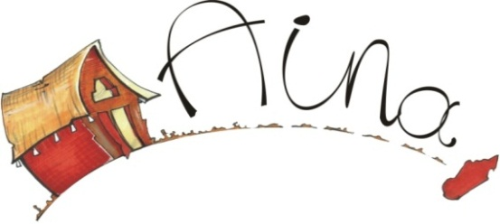

www.aina-madagascar.org

**AINA MADAGASCAR**

**TAKE PART IN BERAVINA COMMUNITY SCHOOL**

Beravina community school is built by **AINA MADAGASCAR**; it is a non-traditional school with a different curriculum and methods from the formal one. The main goal is to achieve widespread primary education for, with high standards level in quality and efficiency as well as stimulate creativity, in that case give the Beravina kids to believe again in their dreams and make them into reality

There are many ways getting involved in that project:

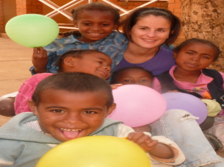**Vibrant meetings :**

Joining **AINA MADAGASCAR**’s trip gives you an opportunity to take part in our volunteer program at Beravina community school. This is an occasion for individuals, couples, friends …to share skills, knowledge, to pupils. Helping children with their homework, teaching Basic English, art, music …

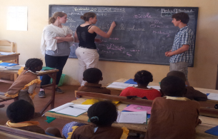**Solidarity groups :**

To group of people who embrace the same goals and interests (college or University students on summer break, commercials organizations, NGOs, Sports teams, group of friends …) Art, Music, Basic English, Intercultural exchange, self-improvement games, creativity practice should be shared to the Beravina children

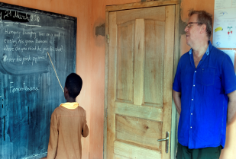**Volunteers :**

People who want to devote their time, energy, knowledge and staying for a longer time (01 to 03 months). A way to understand deeply the culture of Madagascar, exchange ideas & values with locals, understand the impact of political & historical to locals, explore way of building links, learn Malagasy language. Basic English, Art, music, creativity practice, intercultural change should be taught to the Beravina pupils.

**Good will :**

****For those who share out our values, ideas and goals although cannot travel to Madagascar and want to act and contribute morally or financially to **AINA MADAGASCAR’s** solidarity projects.